**Gradient Descent Intuition**

In this video we explored the scenario where we used one parameter θ1 and plotted its cost function to implement a gradient descent. Our formula for a single parameter was :

Repeat until convergence:

|  |
| --- |
|  |

Regardless of the slope's sign for , *θ*1 eventually converges to its minimum value. The following graph shows that when the slope is negative, the value of *θ*1 increases and when it is positive, the value of *θ*1 decreases.

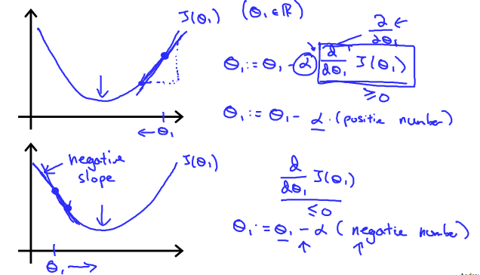

On a side note, we should adjust our parameter *α* to ensure that the gradient descent algorithm converges in a reasonable time. Failure to converge or too much time to obtain the minimum value imply that our step size is wrong.

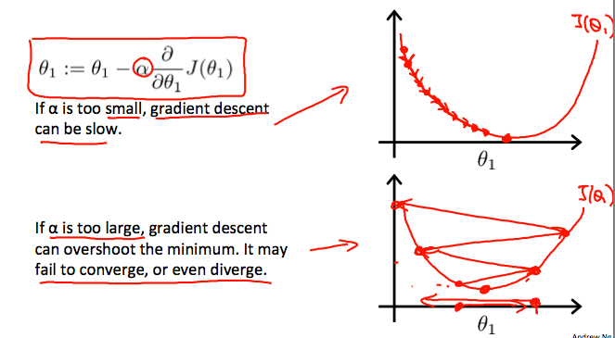

**How does gradient descent converge with a fixed step size α?**

The intuition behind the convergence is that  approaches 0 as we approach the bottom of our convex function. At the minimum, the derivative will always be 0 and thus we get:

|  |
| --- |
| *θ*1 := *θ*1 − *α*∗0 |

